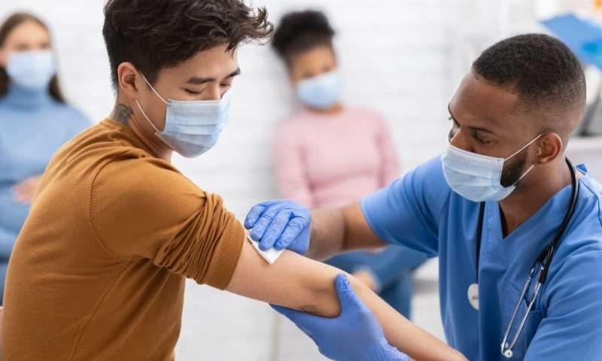
VACImpact® is a nationwide strategic educational initiative to inform, engage and build a trust wall in communities of color on taking the COVID-19 Vaccine, when it becomes available to the nation. Through a series of partnerships New Direction HealthCare Solution will mobilize teams of workers and develop a public relations campaign to prepare people of color, especially, African Americans, to voluntarily participate in taking a COVID-19 vaccine. Developing a belief that the COVID-19 vaccine is, “Safe and will combat the illness”, is the mission of the VACImpact® Project. Taking the Vaccine is important. It’s about saving your life, your family’s life and the community. When it’s your turn please get vaccination. We have a volunteer army of professional healthcare providers to include Physicians, Pharmacist, Nurses, Nurse Practitioners C.N.A. Social Workers, Social Service Organizations and Community Volunteers committed and ready to serve! Cynthia J. Finch, LMSW, CCM, CMCE

