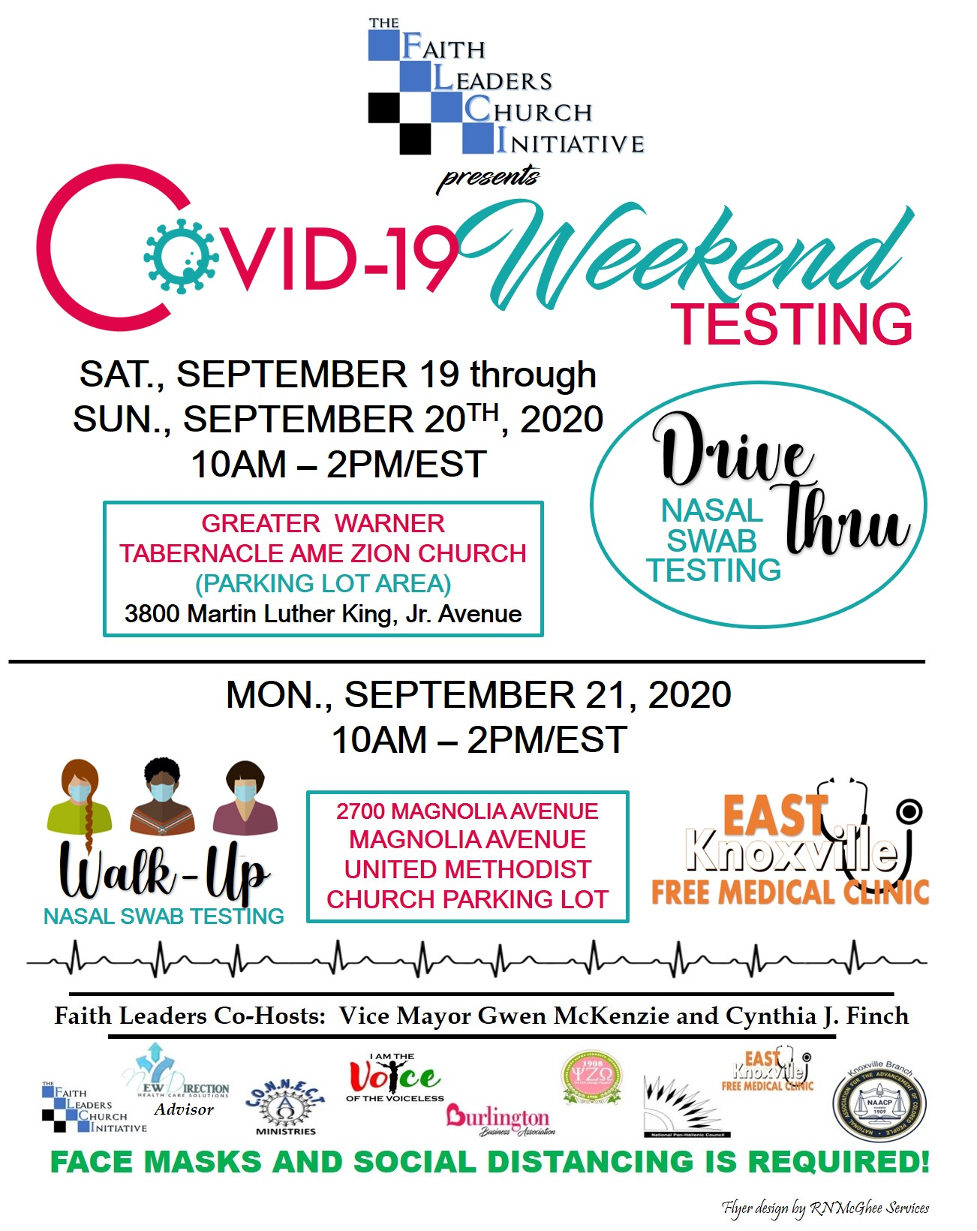
Please save this link. We will use the Link for all future Zooms.
Reminder: Faith Leaders Church Initiative Thursday Zoom/Conference Call
Participants can Zoom-In or Call-In
Thursdays - 5:00 pm/Est - 6:00 pm/Est

IMPORTANT Update: Vaccine Distribution
Update on the African American Health Care Clinician COVID-19 Workgroup
VACImpact - Vaccine Educational Outreach
Join Zoom Meeting
https://us02web.zoom.us/j/88507747691?pwd=RkdOVk12SWhzRG1zKzd1VU0zZ0w4UT09
Meeting ID: 885 0774 7691
Passcode: 990242
Conference Call-In Number:
+1 312- 626-6799
Meeting ID: 885 0774 7691
Find your local number: https://us02web.zoom.us/u/kjp6lp00V
Please save this Zoom link and the Conference Call-In Number. We will use these links from this point forward. Invite others to join us on these very important discussions.
Major Discussion:
- Vaccine Distribution
- Where you fall in the available to get a vaccine
- Is it safe!
- The Health Care Clinician VACCINE Commission - Focusing on People of Color and the undeserved and underrepresented
- Training about the VACCINE and Train the Trainers
- How To Volunteer!

